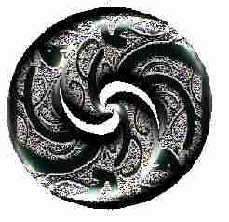Winson 2004

Lou Capewell & Kelly Martin are two Maori Grandmothers from New Zealand, they want to share the challenges facing their people as well as experiences and successes. They are interested in meeting informally with people, especially Native people working in social welfare, health and adult education, and sharing stories of traditional lore and law of indigenous Aotearoa and America. They have been working with tikanga-a-iwi, meaning, the ways of doing and thinking held by the different tribes of Aotearoa to be just and correct - the RIGHT tribal ways. One of the experiences they have to share is Kai-Awhina: Maramarua Kohanga Reo (Native Language Nest). They are also committed to Family Group Conferencing/Family Group Decision Making. They have two books called Grandmother's Broom. Copies of their books will be available.
Lou Herwini-Capewell is affiliated to tribes within the greater Northland tribe of Ngapuhi, North Island, Aotearoa (NZ). She is currently residing in the Auckland area, Aotearoa (NZ). Lou is a Registered Psychiatric Nurse and Trainer/Educator/Facilitator with experience working with drug dependency and Fetal Alcohol Syndrome issues.
Kelly Toa-Martin is affiliated to Ngati Maniapoto - a tribe of the Tainui-Waka Confederation of Tribes, North Island, Aotearoa (NZ) - and Ngati Mutunga - a tribe of the of the Taranaki area of the West Coast, North Island, Aotearoa (NZ). She is currently residing in the Auckland area, Aotearoa (NZ). Kelly is a Trainer/Educator. Her field is Social & Community Work with experience working with crisis intervention, rape crisis services, and drug dependency and Fetal Alcohol Syndrome issues.
Lou & Kelly work through the auspices of Whakato Te Wairua Charitable Trust

